

**Проект**

**По**

**„Програмиране на бази данни“**

Студент: Иван Пламенов Колев ФН:21621580 гр.4 III к. СИТ

Описание

Проектът представлява приложение за управление на сайт за коли под наем с различни функции.

1. **Заявка за налични автомобили:** Потребителите могат да пускат заявка за наличен автомобил, като сложат филтри, като дата, час и др.
2. **Резервация на автомобил:** Избор на автомобил по марка, модел и наличност в избраните дати.
3. **Редакция на резервация:** Промяна на вече направена резервация, като промяна на автомобил, дата, час и други детайли по резервацията, ако е възможно.
4. **Изтриване на резервация:** Потребителите могат да изтриват вече направени резервации от тях.
5. **Справки:** Последни 10 отдавания, наети автомобили от клиент, отдадени автомобили от служител.

**2.Модели на БД с пояснения за таблиците**

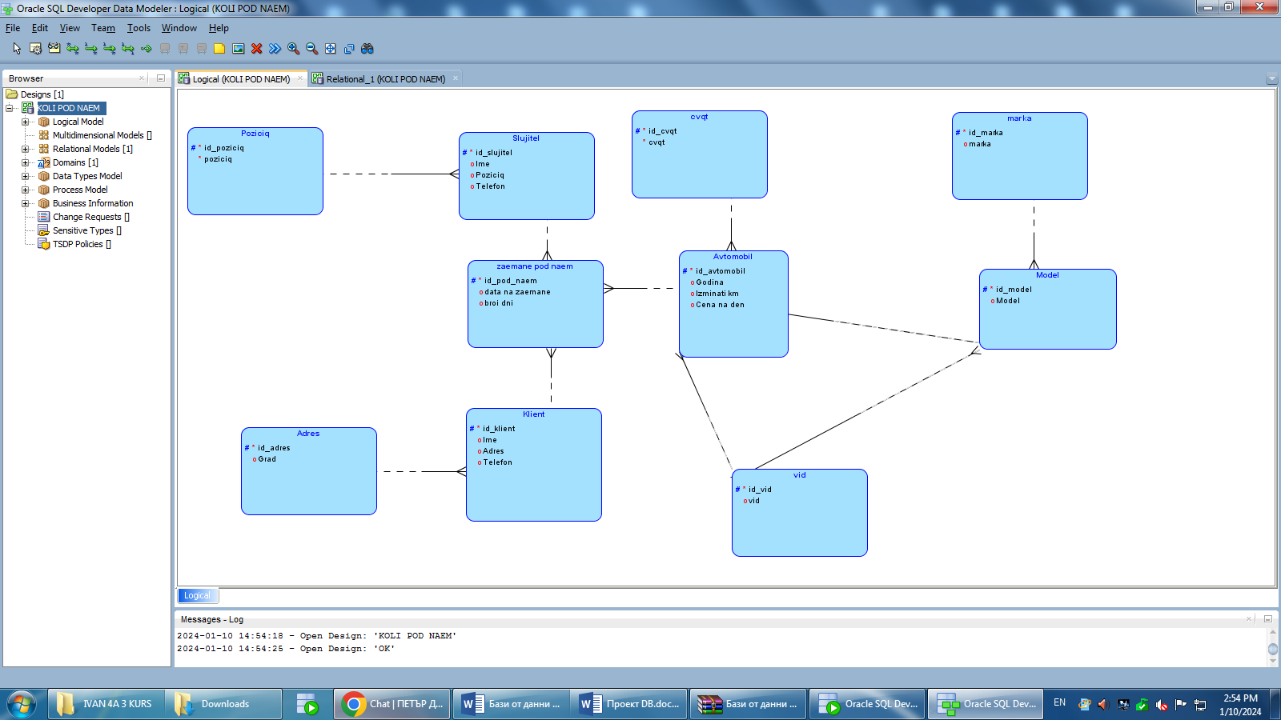

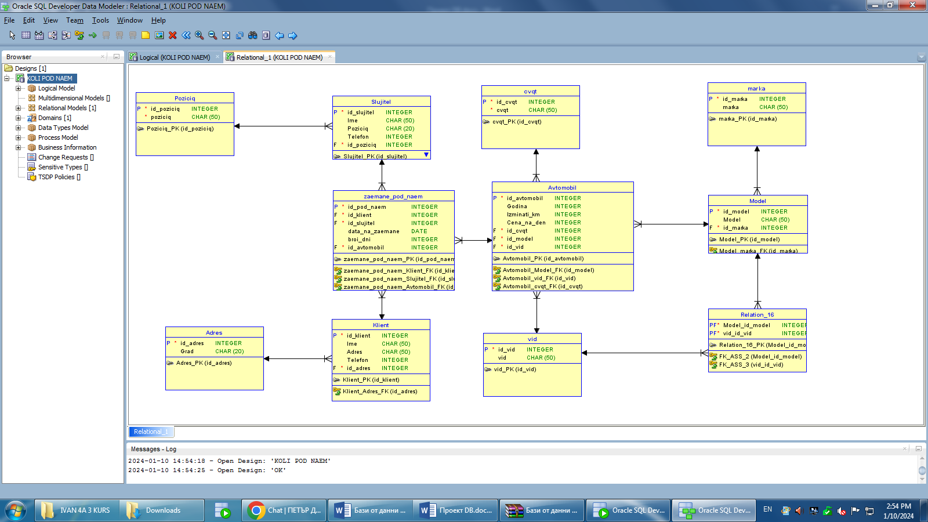

1. Zaemane pod name:

* Id_pod_naem: уникален идентификатор за отдаване под наем.
* Data_na_zaemane: датата на заемане на автомобил.
* Broi_dni: период от време, в който даден автомобил ще бъде отдаден под наем.

1. Slujitel:

* Id_slujitel: уникален идентификатор на служителя.
* Ime: име на служител.
* Poziciq:позицията, която заема даден служител.
* Telefon: телефонен номер на служител.

1. Poziciq:

* Id_poziciq: уникален идентификатор на позицията.
* Poziciq: позицията на служител във фирмата.

1. Klient:

* Id_klient: уникален идентификатор на клиент.
* Ime: име на клиент.
* Adres: Адрес на клиент.
* Telefon: телефонен номер на клиент.

1. Adres:

* Id_adres: уникален идентификатор за адреса на клиент.
* Grad: градът, в който живее клиента.

1. Аvtomobili:

* Id_avtomobili: уникален идентификатор на автомобила.
* Godina: година на производство на автомобила.
* Izminati_kilometri: изминати километри на автомобила от датата на производство.
* Cena_na_den: Цена на автомобила за отдаване под наем за един ден.

1. Cvqt:

* Id_cvqt: уникален идентификатор за цветовете на автомобилите.
* Cvqt: цвят на автомобила.

1. Vid:

* Id_vid: уникален идентификатор за вида на автомобила.
* Vid: вид на автомобила(седан, купе, комби и тн.).

1. Model:

* Id_model:уникален идентификатор за модела на автомобила.
* Model:Модел на автомобила, като допълнение на марката.

10.Marka:

* Id_marka:уникален идентификатор за марката на автомобила.
* Marka: марка на автомобила(ауди, мерцедес, бмв).

11.Relation 16: връзката между марка и вид на автомобила.

**3. Кратко описание на избраните средства за реализация на пркекта**

Избрах HTML, CSS, PHP, MySQL за създаването на това приложение. HTML и CSS изиграха главна роля в създаването на потребителския интерфейс. PHP помогна за изработването на функционалностите а MySQL помогна за съхраняването на информацията.

**4. Код на базата данни**

CREATE TABLE Adres

( id_adres INTEGER NOT NULL , Grad CHAR (20)

) ;

ALTER TABLE Adres ADD CONSTRAINT Adres_PK PRIMARY KEY ( id_adres ) ;

CREATE TABLE Avtomobil

(

id_avtomobil INTEGER NOT NULL ,

Godina INTEGER ,

Izminati_km INTEGER ,

Cena_na_den INTEGER ,

id_cvqt INTEGER NOT NULL ,

id_model INTEGER NOT NULL ,

id_vid INTEGER NOT NULL

) ;

ALTER TABLE Avtomobil ADD CONSTRAINT Avtomobil_PK PRIMARY KEY ( id_avtomobil ) ;

CREATE TABLE Klient

(

id_klient INTEGER NOT NULL ,

Ime CHAR (50) ,

Adres CHAR (50) ,

Telefon INTEGER ,

id_adres INTEGER NOT NULL

) ;

ALTER TABLE Klient ADD CONSTRAINT Klient_PK PRIMARY KEY ( id_klient ) ;

CREATE TABLE Model

(

id_model INTEGER NOT NULL ,

Model CHAR (50) ,

id_marka INTEGER NOT NULL

) ;

ALTER TABLE Model ADD CONSTRAINT Model_PK PRIMARY KEY ( id_model ) ;

CREATE TABLE Poziciq

(

id_poziciq INTEGER NOT NULL ,

poziciq CHAR (50) NOT NULL

) ;

ALTER TABLE Poziciq ADD CONSTRAINT Poziciq_PK PRIMARY KEY ( id_poziciq ) ;

CREATE TABLE Relation_16

(

Model_id_model INTEGER NOT NULL ,

vid_id_vid INTEGER NOT NULL

) ;

ALTER TABLE Relation_16 ADD CONSTRAINT Relation_16_PK PRIMARY KEY ( Model_id_model, vid_id_vid ) ;

CREATE TABLE Slujitel

(

id_slujitel INTEGER NOT NULL ,

Ime CHAR (50) ,

Poziciq CHAR (20) ,

Telefon INTEGER ,

id_poziciq INTEGER NOT NULL

) ;

ALTER TABLE Slujitel ADD CONSTRAINT Slujitel_PK PRIMARY KEY ( id_slujitel ) ;

CREATE TABLE cvqt

( id_cvqt INTEGER NOT NULL , cvqt CHAR (50) NOT NULL

) ;

ALTER TABLE cvqt ADD CONSTRAINT cvqt_PK PRIMARY KEY ( id_cvqt ) ;

CREATE TABLE marka

( id_marka INTEGER NOT NULL , marka CHAR (50)

) ;

ALTER TABLE marka ADD CONSTRAINT marka_PK PRIMARY KEY ( id_marka ) ;

CREATE TABLE vid

( id_vid INTEGER NOT NULL , vid CHAR (50)

) ;

ALTER TABLE vid ADD CONSTRAINT vid_PK PRIMARY KEY ( id_vid ) ;

CREATE TABLE zaemane_pod_naem

(

id_pod_naem INTEGER NOT NULL ,

id_klient INTEGER NOT NULL ,

id_slujitel INTEGER NOT NULL ,

data_na_zaemane DATE ,

broi_dni INTEGER ,

id_avtomobil INTEGER NOT NULL

) ;

**3.Създаване на връзки между таблиците**

ALTER TABLE zaemane_pod_naem ADD CONSTRAINT zaemane_pod_naem_PK PRIMARY KEY ( id_pod_naem ) ;

ALTER TABLE Avtomobil ADD CONSTRAINT Avtomobil_Model_FK FOREIGN KEY ( id_model ) REFERENCES Model ( id_model ) ;

ALTER TABLE Avtomobil ADD CONSTRAINT Avtomobil_cvqt_FK FOREIGN KEY ( id_cvqt ) REFERENCES cvqt ( id_cvqt ) ;

ALTER TABLE Avtomobil ADD CONSTRAINT Avtomobil_vid_FK FOREIGN KEY ( id_vid ) REFERENCES vid ( id_vid ) ;

ALTER TABLE Relation_16 ADD CONSTRAINT FK_ASS_2 FOREIGN KEY ( Model_id_model ) REFERENCES Model ( id_model ) ;

ALTER TABLE Relation_16 ADD CONSTRAINT FK_ASS_3 FOREIGN KEY ( vid_id_vid ) REFERENCES vid ( id_vid ) ;

ALTER TABLE Klient ADD CONSTRAINT Klient_Adres_FK FOREIGN KEY ( id_adres ) REFERENCES Adres ( id_adres ) ;

ALTER TABLE Model ADD CONSTRAINT Model_marka_FK FOREIGN KEY ( id_marka ) REFERENCES marka ( id_marka ) ;

ALTER TABLE Slujitel ADD CONSTRAINT Slujitel_Poziciq_FK FOREIGN KEY ( id_poziciq ) REFERENCES Poziciq ( id_poziciq ) ;

ALTER TABLE zaemane_pod_naem ADD CONSTRAINT zaemane_pod_naem_Avtomobil_FK FOREIGN KEY ( id_avtomobil ) REFERENCES Avtomobil ( id_avtomobil ) ;

ALTER TABLE zaemane_pod_naem ADD CONSTRAINT zaemane_pod_naem_Klient_FK FOREIGN KEY ( id_klient ) REFERENCES Klient ( id_klient ) ;

ALTER TABLE zaemane_pod_naem ADD CONSTRAINT zaemane_pod_naem_Slujitel_FK FOREIGN KEY ( id_slujitel ) REFERENCES Slujitel ( id_slujitel ) ;

**4.Процедури**

CREATE OR REPLACE PROCEDURE "ADR_INS"

(v_GRAD ADRES.grad%TYPE)

AS

BEGIN

INSERT INTO ADRES(grad)

Values (v_grad);

END;

--------------------------------------------------------

-- DDL for Procedure ADR_UPD

--------------------------------------------------------

set define off;

CREATE OR REPLACE PROCEDURE "ADR_UPD"

(v_id_adres ADRES.id_adres%TYPE,

v_grad ADRES.grad%TYPE)

AS

BEGIN

UPDATE ADRES set grad= v_grad

where id_adres= v_id_adres;

END;

--------------------------------------------------------

-- DDL for Procedure AVT_INS

--------------------------------------------------------

set define off;

CREATE OR REPLACE PROCEDURE "AVT_INS"

(v_godina AVTOMOBIL.godina%TYPE,

v_izminati_km AVTOMOBIL.izminati_km%TYPE,

v_cena_na_den AVTOMOBIL.cena_na_den%TYPE,

v_CVQT AVTOMOBIL.ID_CVQT%TYPE,

v_MODEL AVTOMOBIL.ID_MODEL%TYPE,

v_VID AVTOMOBIL.ID_VID%TYPE)

AS

BEGIN

INSERT INTO AVTOMOBIL(godina, izminati_km, cena_na_den, ID_CVQT, ID_MODEL, ID_VID)

Values (v_godina, v_izminati_km,v_cena_na_den, v_CVQT, v_MODEL, v_VID);

END;

--------------------------------------------------------

-- DDL for Procedure AVT_UPD

--------------------------------------------------------

set define off;

CREATE OR REPLACE PROCEDURE "AVT_UPD"

(v_id_avtomobil AVTOMOBIL.id_avtomobil%TYPE,

v_godina AVTOMOBIL.godina%TYPE,

v_izminati_km AVTOMOBIL.izminati_km%TYPE,

v_cena_na_den AVTOMOBIL.cena_na_den%TYPE,

v_CVQT AVTOMOBIL.ID_CVQT%TYPE,

v_MODEL AVTOMOBIL.ID_MODEL%TYPE,

v_VID AVTOMOBIL.ID_VID%TYPE)

AS

BEGIN

UPDATE AVTOMOBIL set godina= v_godina,

izminati_km= v_izminati_km,

cena_na_den= v_cena_na_den,

id_cvqt= v_CVQT,

id_model= v_model,

id_vid= v_VID

where id_avtomobil= v_id_avtomobil;

END;

--------------------------------------------------------

-- DDL for Procedure CVQT_INS

--------------------------------------------------------

set define off;

CREATE OR REPLACE PROCEDURE "CVQT_INS"

(v_cvqt CVQT.cvqt%TYPE)

AS

BEGIN

INSERT INTO CVQT(cvqt)

Values (v_cvqt);

END;

--------------------------------------------------------

-- DDL for Procedure CVQT_UPD

--------------------------------------------------------

set define off;

CREATE OR REPLACE PROCEDURE "CVQT_UPD"

(v_id_cvqt CVQT.id_cvqt%TYPE,

v_cvqt CVQT.cvqt%TYPE)

AS

BEGIN

UPDATE CVQT set cvqt= v_cvqt

where id_cvqt= v_id_cvqt;

END;

--------------------------------------------------------

-- DDL for Procedure FIND_EMPLOYEE

--------------------------------------------------------

set define off;

CREATE OR REPLACE PROCEDURE "FIND_EMPLOYEE" (KEYWORDS VARCHAR2) IS

KEYWORDS_new VARCHAR2(500);

BEGIN

KEYWORDS_new := '%' || KEYWORDS || '%';

DBMS_OUTPUT.PUT_LINE('Employees whose name contains ' || KEYWORDS);

FOR EMP_RECORD IN (

SELECT s.ime AS slujitel_ime, p.poziciq

FROM slujitel s

JOIN poziciq p ON s.id_poziciq = p.id_poziciq

WHERE s.ime LIKE KEYWORDS_new

)

LOOP

DBMS_OUTPUT.PUT_LINE(EMP_RECORD.slujitel_ime || ' ' || EMP_RECORD.poziciq);

END LOOP;

END FIND_EMPLOYEE;

--------------------------------------------------------

-- DDL for Procedure KLNT_INS

--------------------------------------------------------

set define off;

CREATE OR REPLACE PROCEDURE "KLNT_INS"

(v_ime KLIENT.ime%TYPE,

v_ULICA KLIENT.ULICA%TYPE,

v_telefon KLIENT.telefon%TYPE,

v_id_adres KLIENT.ID_ADRES%TYPE)

AS

BEGIN

INSERT INTO KLIENT(ime, ULICA, telefon, ID_ADRES)

Values (v_ime, v_ULICA, v_telefon, v_id_adres);

END;

--------------------------------------------------------

-- DDL for Procedure MDL_INS

--------------------------------------------------------

set define off;

CREATE OR REPLACE PROCEDURE "MDL_INS"

(v_model MODELL.model%TYPE,

v_MARKA MODELL.ID_MARKA%TYPE)

AS

BEGIN

INSERT INTO MODELL(model, ID_MARKA)

Values (v_model, v_MARKA);

END;

--------------------------------------------------------

-- DDL for Procedure MDL_UPD

--------------------------------------------------------

set define off;

CREATE OR REPLACE PROCEDURE "MDL_UPD"

(v_id_model MODELL.id_model%TYPE,

v_model MODELL.model%TYPE)

AS

BEGIN

UPDATE MODELL set model= v_model

where id_model= v_id_model;

END;

--------------------------------------------------------

-- DDL for Procedure MODEL_TYPE_INS

--------------------------------------------------------

set define off;

CREATE OR REPLACE PROCEDURE "MODEL_TYPE_INS"

(v_model_id_model Model_Type.model_id_model%TYPE,

v_vid_id_vid Model_Type.vid_id_vid%TYPE)

AS

BEGIN

INSERT INTO Model_Type(model_id_model, vid_id_vid)

Values (v_model_id_model, v_vid_id_vid);

END;

--------------------------------------------------------

-- DDL for Procedure MRK_INS

--------------------------------------------------------

set define off;

CREATE OR REPLACE PROCEDURE "MRK_INS"

(v_marka MARKA.marka%TYPE)

AS

BEGIN

INSERT INTO MARKA(marka)

Values (v_marka);

END;

--------------------------------------------------------

-- DDL for Procedure MRK_UPD

--------------------------------------------------------

set define off;

CREATE OR REPLACE PROCEDURE "MRK_UPD"

(v_id_marka MARKA.id_marka%TYPE,

v_marka MARKA.marka%TYPE)

AS

BEGIN

UPDATE MARKA set marka= v_marka

where id_marka= v_id_marka;

END;

--------------------------------------------------------

-- DDL for Procedure POS_INS

--------------------------------------------------------

set define off;

CREATE OR REPLACE PROCEDURE "POS_INS"

(v_poziciq POZICIQ.poziciq%TYPE,

v_zaplata POZICIQ.zaplata%TYPE)

AS

BEGIN

INSERT INTO POZICIQ(poziciq, zaplata)

Values (v_poziciq, v_zaplata);

END;

--------------------------------------------------------

-- DDL for Procedure POS_UPD

--------------------------------------------------------

set define off;

CREATE OR REPLACE PROCEDURE "POS_UPD"

(v_id_poziciq POZICIQ.poziciq%TYPE,

v_poziciq POZICIQ.poziciq%TYPE,

v_zaplata POZICIQ.zaplata%TYPE)

AS

BEGIN

UPDATE POZICIQ set poziciq= v_poziciq,

zaplata= v_zaplata

where id_poziciq= v_id_poziciq;

END;

--------------------------------------------------------

-- DDL for Procedure SLUJ_INS

--------------------------------------------------------

set define off;

CREATE OR REPLACE PROCEDURE "SLUJ_INS"

(v_ime SLUJITEL.ime%TYPE,

v_poziciq SLUJITEL.poziciq%TYPE,

v_telefon SLUJITEL.telefon%TYPE,

v_id_poziciq SLUJITEL.ID_POZICIQ%TYPE)

AS

BEGIN

INSERT INTO SLUJITEL(ime, poziciq, telefon, ID_POZICIQ)

Values (v_ime, v_poziciq, v_telefon, v_id_poziciq);

END;

--------------------------------------------------------

-- DDL for Procedure SLUJ_UPD

--------------------------------------------------------

set define off;

CREATE OR REPLACE PROCEDURE "SLUJ_UPD"

(v_id_slujitel SLUJITEL.id_slujitel%TYPE,

v_ime SLUJITEL.ime%TYPE,

v_poziciq SLUJITEL.poziciq%TYPE,

v_telefon SLUJITEL.telefon%TYPE,

v_id_poziciq SLUJITEL.ID_POZICIQ%TYPE)

AS

BEGIN

UPDATE SLUJITEL set ime= v_ime,

poziciq= v_poziciq,

telefon= v_telefon,

id_poziciq= v_id_poziciq

where id_slujitel= v_id_slujitel;

END;

--------------------------------------------------------

-- DDL for Procedure SPR_EMPL_POS

--------------------------------------------------------

set define off;

CREATE OR REPLACE PROCEDURE "SPR_EMPL_POS" (V_POS_NAME slujitel.poziciq%TYPE) IS

BEGIN

DBMS_OUTPUT.PUT_LINE('Employees with ' || V_POS_NAME || ' position');

FOR EMP_RECORD IN (

SELECT s.ime AS slujitel_ime

FROM slujitel s

JOIN poziciq p ON s.id_poziciq = p.id_poziciq

WHERE p.poziciq = V_POS_NAME

)

LOOP

DBMS_OUTPUT.PUT_LINE(EMP_RECORD.slujitel_ime);

END LOOP;

END spr_Empl_pos;

--------------------------------------------------------

-- DDL for Procedure VID_INS

--------------------------------------------------------

set define off;

CREATE OR REPLACE PROCEDURE "VID_INS"

(v_vid VID.vid%TYPE)

AS

BEGIN

INSERT INTO VID(vid)

Values (v_vid);

END;

--------------------------------------------------------

-- DDL for Procedure VID_UPD

--------------------------------------------------------

set define off;

CREATE OR REPLACE PROCEDURE "VID_UPD"

(v_id_vid VID.id_vid%TYPE,

v_vid VID.vid%TYPE)

AS

BEGIN

UPDATE VID set vid= v_vid

where id_vid= v_id_vid;

END;

--------------------------------------------------------

-- DDL for Procedure ZPD_INS

--------------------------------------------------------

set define off;

CREATE OR REPLACE PROCEDURE "ZPD_INS"

(v_id_klient ZAEMANE_POD_NAEM.id_klient%TYPE,

v_id_slujitel ZAEMANE_POD_NAEM.id_slujitel%TYPE,

v_data_na_zaemane ZAEMANE_POD_NAEM.data_na_zaemane%TYPE,

v_broi_dni ZAEMANE_POD_NAEM.broi_dni%TYPE,

v_id_avtomobil ZAEMANE_POD_NAEM.ID_AVTOMOBIL%TYPE)

AS

BEGIN

INSERT INTO ZAEMANE_POD_NAEM(ID_KLIENT, ID_SLUJITEL, data_na_zaemane, broi_dni, ID_AVTOMOBIL)

Values (v_id_klient, v_id_slujitel, v_data_na_zaemane, v_broi_dni, v_id_avtomobil);

END;

--------------------------------------------------------

-- DDL for Procedure ZPD_UPD

--------------------------------------------------------

set define off;

CREATE OR REPLACE PROCEDURE "ZPD_UPD"

(v_id_pod_naem ZAEMANE_POD_NAEM.id_pod_naem%TYPE,

v_data_na_zaemane ZAEMANE_POD_NAEM.data_na_zaemane%TYPE,

v_broi_dni ZAEMANE_POD_NAEM.broi_dni%TYPE,

v_id_klient ZAEMANE_POD_NAEM.id_klient%TYPE,

v_id_slujitel ZAEMANE_POD_NAEM.id_slujitel%TYPE,

v_id_avtomobil ZAEMANE_POD_NAEM.ID_AVTOMOBIL%TYPE)

AS

BEGIN

UPDATE ZAEMANE_POD_NAEM set data_na_zaemane= v_data_na_zaemane,

broi_dni= v_broi_dni,

id_klient = v_id_klient,

ID_SLUJITEL= v_id_slujitel,

ID_AVTOMOBIL= v_id_avtomobil

where id_pod_naem= v_id_pod_naem;

END;

**5.Sequenc-и за Trigger-ите**

CREATE SEQUENCE "ADR_SEQ" MINVALUE 1 MAXVALUE 999999999999999999999999999 INCREMENT BY 1 START WITH 21 CACHE 20 NOORDER NOCYCLE

--------------------------------------------------------

-- DDL for Sequence AVT_SEQ

--------------------------------------------------------

CREATE SEQUENCE "AVT_SEQ" MINVALUE 1 MAXVALUE 999999999999999999999999999 INCREMENT BY 1 START WITH 21 CACHE 20 NOORDER NOCYCLE

--------------------------------------------------------

-- DDL for Sequence CVQT_SEQ

--------------------------------------------------------

CREATE SEQUENCE "CVQT_SEQ" MINVALUE 1 MAXVALUE 999999999999999999999999999 INCREMENT BY 1 START WITH 21 CACHE 20 NOORDER NOCYCLE

--------------------------------------------------------

-- DDL for Sequence KLNT_SEQ

--------------------------------------------------------

CREATE SEQUENCE "KLNT_SEQ" MINVALUE 1 MAXVALUE 999999999999999999999999999 INCREMENT BY 1 START WITH 21 CACHE 20 NOORDER NOCYCLE

--------------------------------------------------------

-- DDL for Sequence MDL_SEQ

--------------------------------------------------------

CREATE SEQUENCE "MDL_SEQ" MINVALUE 1 MAXVALUE 999999999999999999999999999 INCREMENT BY 1 START WITH 21 CACHE 20 NOORDER NOCYCLE

--------------------------------------------------------

-- DDL for Sequence MRK_SEQ

--------------------------------------------------------

CREATE SEQUENCE "MRK_SEQ" MINVALUE 1 MAXVALUE 999999999999999999999999999 INCREMENT BY 1 START WITH 21 CACHE 20 NOORDER NOCYCLE

--------------------------------------------------------

-- DDL for Sequence POS_SEQ

--------------------------------------------------------

CREATE SEQUENCE "POS_SEQ" MINVALUE 1 MAXVALUE 999999999999999999999999999 INCREMENT BY 1 START WITH 21 CACHE 20 NOORDER NOCYCLE

--------------------------------------------------------

-- DDL for Sequence SLUJ_SEQ

--------------------------------------------------------

CREATE SEQUENCE "SLUJ_SEQ" MINVALUE 1 MAXVALUE 999999999999999999999999999 INCREMENT BY 1 START WITH 21 CACHE 20 NOORDER NOCYCLE

--------------------------------------------------------

-- DDL for Sequence VID_SEQ

--------------------------------------------------------

CREATE SEQUENCE "VID_SEQ" MINVALUE 1 MAXVALUE 999999999999999999999999999 INCREMENT BY 1 START WITH 21 CACHE 20 NOORDER NOCYCLE

--------------------------------------------------------

-- DDL for Sequence ZPD_SEQ

--------------------------------------------------------

CREATE SEQUENCE "ZPD_SEQ" MINVALUE 1 MAXVALUE 999999999999999999999999999 INCREMENT BY 1 START WITH 21 CACHE 20 NOORDER NOCYCLE

--------------------------------------------------------

-- DDL for Table ADRES

--------------------------------------------------------

CREATE TABLE "ADRES" ("ID_ADRES" NUMBER(*,0), "GRAD" CHAR(20))

--------------------------------------------------------

-- DDL for Table AVTOMOBIL

--------------------------------------------------------

CREATE TABLE "AVTOMOBIL" ("ID_AVTOMOBIL" NUMBER(*,0), "GODINA" NUMBER(*,0), "IZMINATI_KM" NUMBER(*,0), "CENA_NA_DEN" NUMBER(*,0), "ID_CVQT" NUMBER(*,0), "ID_MODEL" NUMBER(*,0), "ID_VID" NUMBER(*,0))

--------------------------------------------------------

-- DDL for Table CVQT

--------------------------------------------------------

CREATE TABLE "CVQT" ("ID_CVQT" NUMBER(*,0), "CVQT" CHAR(50))

--------------------------------------------------------

-- DDL for Table KLIENT

--------------------------------------------------------

CREATE TABLE "KLIENT" ("ID_KLIENT" NUMBER(*,0), "IME" CHAR(50), "ULICA" CHAR(50), "TELEFON" NUMBER(*,0), "ID_ADRES" NUMBER(*,0))

--------------------------------------------------------

-- DDL for Table MARKA

--------------------------------------------------------

CREATE TABLE "MARKA" ("ID_MARKA" NUMBER(*,0), "MARKA" CHAR(50))

--------------------------------------------------------

-- DDL for Table MODELL

--------------------------------------------------------

CREATE TABLE "MODELL" ("ID_MODEL" NUMBER(*,0), "MODEL" CHAR(50), "ID_MARKA" NUMBER(*,0))

--------------------------------------------------------

-- DDL for Table MODEL_TYPE

--------------------------------------------------------

CREATE TABLE "MODEL_TYPE" ("MODEL_ID_MODEL" NUMBER(*,0), "VID_ID_VID" NUMBER(*,0))

--------------------------------------------------------

-- DDL for Table POZICIQ

--------------------------------------------------------

CREATE TABLE "POZICIQ" ("ID_POZICIQ" NUMBER(*,0), "POZICIQ" CHAR(50), "ZAPLATA" VARCHAR2(20))

--------------------------------------------------------

-- DDL for Table SLUJITEL

--------------------------------------------------------

CREATE TABLE "SLUJITEL" ("ID_SLUJITEL" NUMBER(*,0), "IME" CHAR(50), "POZICIQ" CHAR(20), "TELEFON" NUMBER(*,0), "ID_POZICIQ" NUMBER(*,0))

--------------------------------------------------------

-- DDL for Table VID

--------------------------------------------------------

CREATE TABLE "VID" ("ID_VID" NUMBER(*,0), "VID" CHAR(50))

--------------------------------------------------------

-- DDL for Table ZAEMANE_POD_NAEM

--------------------------------------------------------

**6.Trigger-и**

CREATE OR REPLACE TRIGGER "AFTER_ZAEMANE_POD_NAEM_INS"

AFTER INSERT ON zaemane_pod_naem

FOR EACH ROW

BEGIN

UPDATE avtomobil

SET status = '????'

WHERE id_avtomobil = :NEW.id_avtomobil;

END;

ALTER TRIGGER "AFTER_ZAEMANE_POD_NAEM_INS" ENABLE

--------------------------------------------------------

-- DDL for Trigger BEFORE_ZAEMANE_POD_NAEM_INS

--------------------------------------------------------

CREATE OR REPLACE TRIGGER "BEFORE_ZAEMANE_POD_NAEM_INS"

BEFORE INSERT ON zaemane_pod_naem

FOR EACH ROW

DECLARE

cnt INTEGER;

BEGIN

SELECT COUNT(*)

INTO cnt

FROM zaemane_pod_naem

WHERE id_klient = :NEW.id_klient

AND id_slujitel = :NEW.id_slujitel

AND data_na_zaemane = :NEW.data_na_zaemane

AND broi_dni = :NEW.broi_dni

AND id_avtomobil = :NEW.id_avtomobil;

IF cnt > 0 THEN

RAISE_APPLICATION_ERROR(-20103, 'Duplicate rental record');

END IF;

END;

ALTER TRIGGER "BEFORE_ZAEMANE_POD_NAEM_INS" ENABLE

--------------------------------------------------------

-- DDL for Trigger ID_ADRES_AUTO_TRG

--------------------------------------------------------

CREATE OR REPLACE TRIGGER "ID_ADRES_AUTO_TRG"

BEFORE INSERT ON ADRES

FOR EACH ROW

WHEN (NEW.id_adres IS NULL) BEGIN

:NEW.id_adres := ADR_SEQ.NEXTVAL;

END;

ALTER TRIGGER "ID_ADRES_AUTO_TRG" ENABLE

--------------------------------------------------------

-- DDL for Trigger ID_AVTOMOBIL_AUTO_TRG

--------------------------------------------------------

CREATE OR REPLACE TRIGGER "ID_AVTOMOBIL_AUTO_TRG"

BEFORE INSERT ON AVTOMOBIL

FOR EACH ROW

WHEN (NEW.id_avtomobil IS NULL) BEGIN

:NEW.id_avtomobil := AVT_SEQ.NEXTVAL;

END;

ALTER TRIGGER "ID_AVTOMOBIL_AUTO_TRG" ENABLE

--------------------------------------------------------

-- DDL for Trigger ID_CVQT_AUTO_TRG

--------------------------------------------------------

CREATE OR REPLACE TRIGGER "ID_CVQT_AUTO_TRG"

BEFORE INSERT ON CVQT

FOR EACH ROW

WHEN (NEW.id_cvqt IS NULL) BEGIN

:NEW.id_cvqt := CVQT_SEQ.NEXTVAL;

END;

ALTER TRIGGER "ID_CVQT_AUTO_TRG" ENABLE

--------------------------------------------------------

-- DDL for Trigger ID_KLIENT_AUTO_TRG

--------------------------------------------------------

CREATE OR REPLACE TRIGGER "ID_KLIENT_AUTO_TRG"

BEFORE INSERT ON KLIENT

FOR EACH ROW

WHEN (NEW.id_klient IS NULL) BEGIN

:NEW.id_klient := KLNT_SEQ.NEXTVAL;

END;

ALTER TRIGGER "ID_KLIENT_AUTO_TRG" ENABLE

--------------------------------------------------------

-- DDL for Trigger ID_MARKA_AUTO_TRG

--------------------------------------------------------

CREATE OR REPLACE TRIGGER "ID_MARKA_AUTO_TRG"

BEFORE INSERT ON MARKA

FOR EACH ROW

WHEN (NEW.id_marka IS NULL) BEGIN

:NEW.id_marka := MRK_SEQ.NEXTVAL;

END;

ALTER TRIGGER "ID_MARKA_AUTO_TRG" ENABLE

--------------------------------------------------------

-- DDL for Trigger ID_MODEL_AUTO_TRG

--------------------------------------------------------

CREATE OR REPLACE TRIGGER "ID_MODEL_AUTO_TRG"

BEFORE INSERT ON MODELL

FOR EACH ROW

WHEN (NEW.id_model IS NULL) BEGIN

:NEW.id_model := MDL_SEQ.NEXTVAL;

END;

ALTER TRIGGER "ID_MODEL_AUTO_TRG" ENABLE

--------------------------------------------------------

-- DDL for Trigger ID_POD_NAEM_AUTO_TRG

--------------------------------------------------------

CREATE OR REPLACE TRIGGER "ID_POD_NAEM_AUTO_TRG"

BEFORE INSERT ON ZAEMANE_POD_NAEM

FOR EACH ROW

WHEN (NEW.id_pod_naem IS NULL) BEGIN

:NEW.id_pod_naem := ZPD_SEQ.NEXTVAL;

END;

ALTER TRIGGER "ID_POD_NAEM_AUTO_TRG" ENABLE

--------------------------------------------------------

-- DDL for Trigger ID_POZICIQ_AUTO_TRG

--------------------------------------------------------

CREATE OR REPLACE TRIGGER "ID_POZICIQ_AUTO_TRG"

BEFORE INSERT ON Poziciq

FOR EACH ROW

WHEN (NEW.id_poziciq IS NULL) BEGIN:NEW.id_poziciq := POS_SEQ.NEXTVAL;

END;

ALTER TRIGGER "ID_POZICIQ_AUTO_TRG" ENABLE

--------------------------------------------------------

-- DDL for Trigger ID_SLUJITEL_AUTO_TRG

--------------------------------------------------------

CREATE OR REPLACE TRIGGER "ID_SLUJITEL_AUTO_TRG"

BEFORE INSERT ON SLUJITEL

FOR EACH ROW

WHEN (NEW.id_slujitel IS NULL) BEGIN

:NEW.id_slujitel := SLUJ_SEQ.NEXTVAL;

END;

ALTER TRIGGER "ID_SLUJITEL_AUTO_TRG" ENABLE

--------------------------------------------------------

-- DDL for Trigger ID_VID_AUTO_TRG

--------------------------------------------------------

CREATE OR REPLACE TRIGGER "ID_VID_AUTO_TRG"

BEFORE INSERT ON VID

FOR EACH ROW

WHEN (NEW.id_vid IS NULL) BEGIN

:NEW.id_vid := VID_SEQ.NEXTVAL;

END;

ALTER TRIGGER "ID_VID_AUTO_TRG" ENABLE

--------------------------------------------------------

-- DDL for Procedure ADR_INS

--------------------------------------------------------

**7.Процедурни справки**

**-отдадени автомобили от служител, подредени по вид и дата**

SELECT

v.vid,

z.data_na_zaemane,

a.godina,

a.izminati_km,

a.cena_na_den,

c.cvqt,

m.marka,

mo.model,

s.ime AS slujitel_ime,

k.ime AS klient_ime

FROM

zaemane_pod_naem z

JOIN

avtomobil a ON z.id_avtomobil = a.id_avtomobil

JOIN

vid v ON a.id_vid = v.id_vid

JOIN

slujitel s ON z.id_slujitel = s.id_slujitel

JOIN

klient k ON z.id_klient = k.id_klient

JOIN

cvqt c ON a.id_cvqt = c.id_cvqt

JOIN

modell mo ON a.id_model = mo.id_model

JOIN

marka m ON mo.id_marka = m.id_marka

ORDER BY

v.vid,

z.data_na_zaemane;

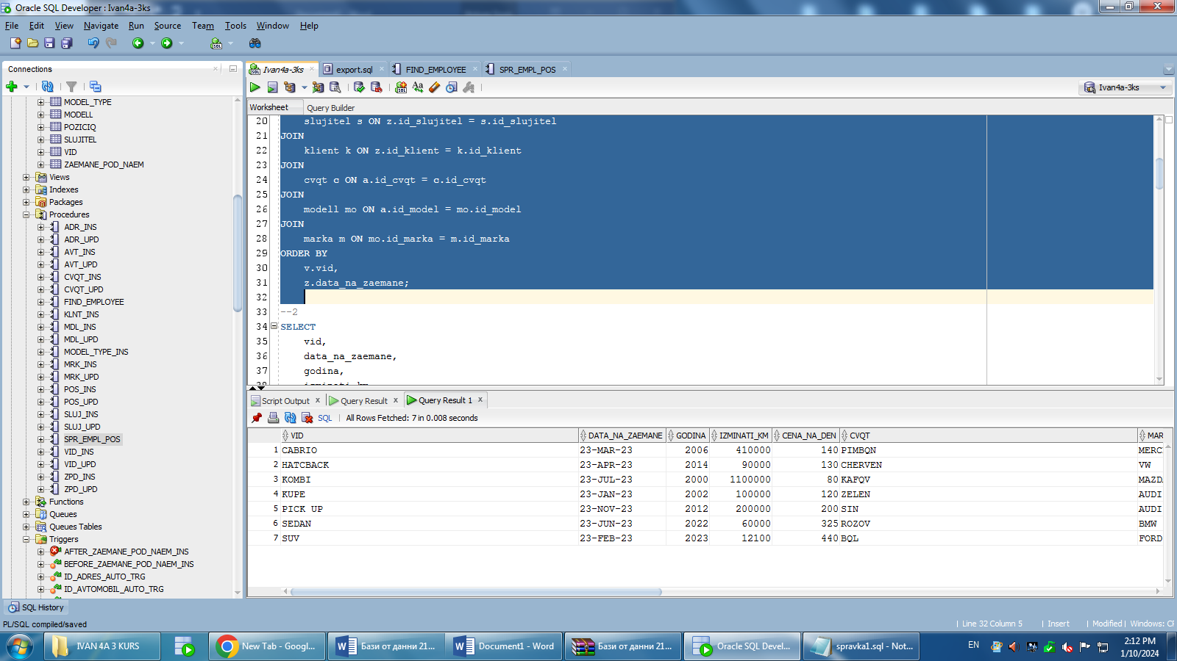

**-последните 10 заемания, подредени по дни**

SELECT

vid,

data_na_zaemane,

godina,

izminati_km,

cena_na_den,

cvqt,

marka,

model,

slujitel_ime,

klient_ime

FROM (

SELECT

v.vid,

z.data_na_zaemane,

a.godina,

a.izminati_km,

a.cena_na_den,

c.cvqt,

m.marka,

mo.model,

s.ime AS slujitel_ime,

k.ime AS klient_ime,

ROW_NUMBER() OVER (ORDER BY z.data_na_zaemane DESC) AS rnum

FROM

zaemane_pod_naem z

JOIN

avtomobil a ON z.id_avtomobil = a.id_avtomobil

JOIN

vid v ON a.id_vid = v.id_vid

JOIN

slujitel s ON z.id_slujitel = s.id_slujitel

JOIN

klient k ON z.id_klient = k.id_klient

JOIN

cvqt c ON a.id_cvqt = c.id_cvqt

JOIN

modell mo ON a.id_model = mo.id_model

JOIN

marka m ON mo.id_marka = m.id_marka

ORDER BY

z.data_na_zaemane DESC

)

WHERE rnum <= 10;

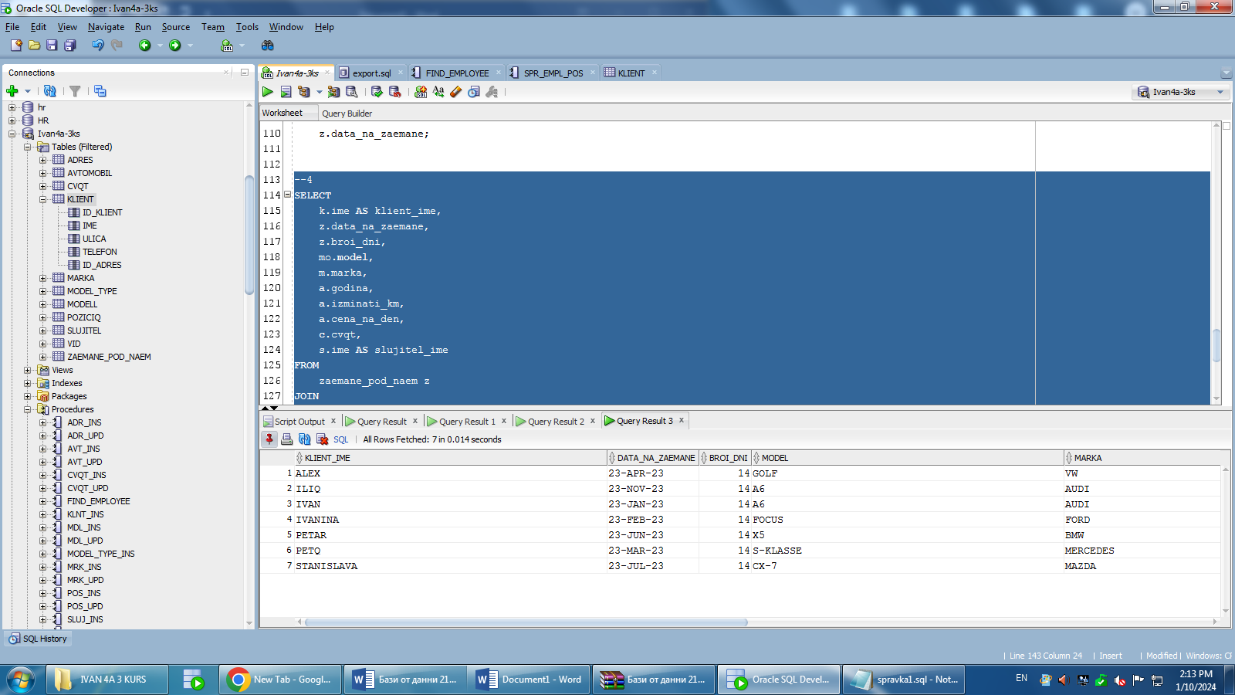

**-наети автомобили от клиент подредени по дата**

SELECT

k.ime AS klient_ime,

z.data_na_zaemane,

z.broi_dni,

mo.model,

m.marka,

a.godina,

a.izminati_km,

a.cena_na_den,

c.cvqt,

s.ime AS slujitel_ime

FROM

zaemane_pod_naem z

JOIN

avtomobil a ON z.id_avtomobil = a.id_avtomobil

JOIN

klient k ON z.id_klient = k.id_klient

JOIN

slujitel s ON z.id_slujitel = s.id_slujitel

JOIN

cvqt c ON a.id_cvqt = c.id_cvqt

JOIN

modell mo ON a.id_model = mo.id_model

JOIN

marka m ON mo.id_marka = m.id_marka

WHERE

z.data_na_zaemane BETWEEN TO_DATE('&начална_дата', 'DD-MM-RR') AND TO_DATE('&крайна_дата', 'DD-MM-RR')

ORDER BY

k.ime,

z.data_na_zaemane;



**7.Специален тригер**create or replace TRIGGER before_zaemane_pod_naem_INS

BEFORE INSERT ON zaemane_pod_naem

FOR EACH ROW

DECLARE

cnt INTEGER;

BEGIN

SELECT COUNT(*)

INTO cnt

FROM zaemane_pod_naem

WHERE id_klient = :NEW.id_klient

AND id_slujitel = :NEW.id_slujitel

AND data_na_zaemane = :NEW.data_na_zaemane

AND broi_dni = :NEW.broi_dni

AND id_avtomobil = :NEW.id_avtomobil;

IF cnt > 0 THEN

RAISE_APPLICATION_ERROR(-20103, 'Duplicate rental record');

END IF;

END;

create or replace TRIGGER after_zaemane_pod_naem_INS

AFTER INSERT ON zaemane_pod_naem

FOR EACH ROW

BEGIN

UPDATE avtomobil

SET status = '¿¿¿¿'

WHERE id_avtomobil = :NEW.id_avtomobil;

END;

**8.Вкарване на данни във таблиците**

REM INSERTING into ADRES

SET DEFINE OFF;

Insert into ADRES (ID_ADRES,GRAD) values (1,'VARNA ');

Insert into ADRES (ID_ADRES,GRAD) values (2,'DOBRICH ');

Insert into ADRES (ID_ADRES,GRAD) values (3,'SILISTRA ');

Insert into ADRES (ID_ADRES,GRAD) values (4,'KOZLODUI ');

Insert into ADRES (ID_ADRES,GRAD) values (5,'YAMBOL ');

Insert into ADRES (ID_ADRES,GRAD) values (6,'POPOVO ');

Insert into ADRES (ID_ADRES,GRAD) values (7,'BURGAS ');

REM INSERTING into AVTOMOBIL

SET DEFINE OFF;

Insert into AVTOMOBIL (ID_AVTOMOBIL,GODINA,IZMINATI_KM,CENA_NA_DEN,ID_CVQT,ID_MODEL,ID_VID) values (1,2002,100000,120,1,1,1);

Insert into AVTOMOBIL (ID_AVTOMOBIL,GODINA,IZMINATI_KM,CENA_NA_DEN,ID_CVQT,ID_MODEL,ID_VID) values (2,2012,200000,200,2,2,2);

Insert into AVTOMOBIL (ID_AVTOMOBIL,GODINA,IZMINATI_KM,CENA_NA_DEN,ID_CVQT,ID_MODEL,ID_VID) values (3,2022,60000,325,3,3,3);

Insert into AVTOMOBIL (ID_AVTOMOBIL,GODINA,IZMINATI_KM,CENA_NA_DEN,ID_CVQT,ID_MODEL,ID_VID) values (4,2000,1100000,80,4,4,4);

Insert into AVTOMOBIL (ID_AVTOMOBIL,GODINA,IZMINATI_KM,CENA_NA_DEN,ID_CVQT,ID_MODEL,ID_VID) values (5,2014,90000,130,5,5,5);

Insert into AVTOMOBIL (ID_AVTOMOBIL,GODINA,IZMINATI_KM,CENA_NA_DEN,ID_CVQT,ID_MODEL,ID_VID) values (6,2023,12100,440,6,6,6);

Insert into AVTOMOBIL (ID_AVTOMOBIL,GODINA,IZMINATI_KM,CENA_NA_DEN,ID_CVQT,ID_MODEL,ID_VID) values (7,2006,410000,140,7,7,7);

REM INSERTING into CVQT

SET DEFINE OFF;

Insert into CVQT (ID_CVQT,CVQT) values (1,'ZELEN ');

Insert into CVQT (ID_CVQT,CVQT) values (2,'SIN ');

Insert into CVQT (ID_CVQT,CVQT) values (3,'ROZOV ');

Insert into CVQT (ID_CVQT,CVQT) values (4,'KAFQV ');

Insert into CVQT (ID_CVQT,CVQT) values (5,'CHERVEN ');

Insert into CVQT (ID_CVQT,CVQT) values (6,'BQL ');

Insert into CVQT (ID_CVQT,CVQT) values (7,'PIMBQN ');

REM INSERTING into KLIENT

SET DEFINE OFF;

Insert into KLIENT (ID_KLIENT,IME,ULICA,TELEFON,ID_ADRES) values (1,'IVAN ','STRUMA ',897769464,1);

Insert into KLIENT (ID_KLIENT,IME,ULICA,TELEFON,ID_ADRES) values (2,'ILIQ ','KOTELOVA ',897723464,2);

Insert into KLIENT (ID_KLIENT,IME,ULICA,TELEFON,ID_ADRES) values (3,'PETAR ','VT ',897545464,3);

Insert into KLIENT (ID_KLIENT,IME,ULICA,TELEFON,ID_ADRES) values (4,'STANISLAVA ','STARA PLANINA ',823769464,4);

Insert into KLIENT (ID_KLIENT,IME,ULICA,TELEFON,ID_ADRES) values (5,'ALEX ','BELOSLAV ',897725564,5);

Insert into KLIENT (ID_KLIENT,IME,ULICA,TELEFON,ID_ADRES) values (6,'IVANINA ','KOZLODUI ',892269464,6);

Insert into KLIENT (ID_KLIENT,IME,ULICA,TELEFON,ID_ADRES) values (7,'PETQ ','CARIGRADSKO ',897769411,7);

REM INSERTING into MARKA

SET DEFINE OFF;

Insert into MARKA (ID_MARKA,MARKA) values (1,'AUDI ');

Insert into MARKA (ID_MARKA,MARKA) values (2,'BMW ');

Insert into MARKA (ID_MARKA,MARKA) values (3,'MAZDA ');

Insert into MARKA (ID_MARKA,MARKA) values (4,'VW ');

Insert into MARKA (ID_MARKA,MARKA) values (5,'FORD ');

Insert into MARKA (ID_MARKA,MARKA) values (6,'MERCEDES ');

Insert into MARKA (ID_MARKA,MARKA) values (7,'ISUZU ');

REM INSERTING into MODELL

SET DEFINE OFF;

Insert into MODELL (ID_MODEL,MODEL,ID_MARKA) values (1,'A6 ',1);

Insert into MODELL (ID_MODEL,MODEL,ID_MARKA) values (2,'A6 ',1);

Insert into MODELL (ID_MODEL,MODEL,ID_MARKA) values (3,'X5 ',2);

Insert into MODELL (ID_MODEL,MODEL,ID_MARKA) values (4,'CX-7 ',3);

Insert into MODELL (ID_MODEL,MODEL,ID_MARKA) values (5,'GOLF ',4);

Insert into MODELL (ID_MODEL,MODEL,ID_MARKA) values (6,'FOCUS ',5);

Insert into MODELL (ID_MODEL,MODEL,ID_MARKA) values (7,'S-KLASSE ',6);

REM INSERTING into MODEL_TYPE

SET DEFINE OFF;

REM INSERTING into POZICIQ

SET DEFINE OFF;

Insert into POZICIQ (ID_POZICIQ,POZICIQ,ZAPLATA) values (1,'BOSS ','10000');

Insert into POZICIQ (ID_POZICIQ,POZICIQ,ZAPLATA) values (2,'CHISTACH ','800');

Insert into POZICIQ (ID_POZICIQ,POZICIQ,ZAPLATA) values (3,'CHETOVODITEL ','2000');

Insert into POZICIQ (ID_POZICIQ,POZICIQ,ZAPLATA) values (4,'UPRAVITEL ','4000');

Insert into POZICIQ (ID_POZICIQ,POZICIQ,ZAPLATA) values (5,'TEHNIK ','1200');

Insert into POZICIQ (ID_POZICIQ,POZICIQ,ZAPLATA) values (6,'RABOTA S KLIENTI ','2100');

Insert into POZICIQ (ID_POZICIQ,POZICIQ,ZAPLATA) values (7,'FRONT OFFICE ','2200');

REM INSERTING into SLUJITEL

SET DEFINE OFF;

Insert into SLUJITEL (ID_SLUJITEL,IME,POZICIQ,TELEFON,ID_POZICIQ) values (1,'ILIAN ','BOSS ',897714264,1);

Insert into SLUJITEL (ID_SLUJITEL,IME,POZICIQ,TELEFON,ID_POZICIQ) values (2,'SUBI ','CHISTACH ',897124214,2);

Insert into SLUJITEL (ID_SLUJITEL,IME,POZICIQ,TELEFON,ID_POZICIQ) values (3,'PETAR ','CHETOVODITEL ',897741264,3);

Insert into SLUJITEL (ID_SLUJITEL,IME,POZICIQ,TELEFON,ID_POZICIQ) values (4,'IVANINA ','UPRAVITEL ',824114264,4);

Insert into SLUJITEL (ID_SLUJITEL,IME,POZICIQ,TELEFON,ID_POZICIQ) values (5,'MARINA ','TEHNIK ',892314264,5);

Insert into SLUJITEL (ID_SLUJITEL,IME,POZICIQ,TELEFON,ID_POZICIQ) values (6,'ISMA ','RABOTA ',872414264,6);

Insert into SLUJITEL (ID_SLUJITEL,IME,POZICIQ,TELEFON,ID_POZICIQ) values (7,'ILARION ','FRONT ',897244264,7);

REM INSERTING into VID

SET DEFINE OFF;

Insert into VID (ID_VID,VID) values (1,'KUPE ');

Insert into VID (ID_VID,VID) values (2,'PICK UP ');

Insert into VID (ID_VID,VID) values (3,'SEDAN ');

Insert into VID (ID_VID,VID) values (4,'KOMBI ');

Insert into VID (ID_VID,VID) values (5,'HATCBACK ');

Insert into VID (ID_VID,VID) values (6,'SUV ');

Insert into VID (ID_VID,VID) values (7,'CABRIO ');

REM INSERTING into ZAEMANE_POD_NAEM

SET DEFINE OFF;

Insert into ZAEMANE_POD_NAEM (ID_POD_NAEM,ID_KLIENT,ID_SLUJITEL,DATA_NA_ZAEMANE,BROI_DNI,ID_AVTOMOBIL) values (2,1,1,to_date('23-JAN-23','DD-MON-RR'),14,1);

Insert into ZAEMANE_POD_NAEM (ID_POD_NAEM,ID_KLIENT,ID_SLUJITEL,DATA_NA_ZAEMANE,BROI_DNI,ID_AVTOMOBIL) values (3,2,2,to_date('23-NOV-23','DD-MON-RR'),14,2);

Insert into ZAEMANE_POD_NAEM (ID_POD_NAEM,ID_KLIENT,ID_SLUJITEL,DATA_NA_ZAEMANE,BROI_DNI,ID_AVTOMOBIL) values (4,3,3,to_date('23-JUN-23','DD-MON-RR'),14,3);

Insert into ZAEMANE_POD_NAEM (ID_POD_NAEM,ID_KLIENT,ID_SLUJITEL,DATA_NA_ZAEMANE,BROI_DNI,ID_AVTOMOBIL) values (5,4,4,to_date('23-JUL-23','DD-MON-RR'),14,4);

Insert into ZAEMANE_POD_NAEM (ID_POD_NAEM,ID_KLIENT,ID_SLUJITEL,DATA_NA_ZAEMANE,BROI_DNI,ID_AVTOMOBIL) values (6,5,5,to_date('23-APR-23','DD-MON-RR'),14,5);

Insert into ZAEMANE_POD_NAEM (ID_POD_NAEM,ID_KLIENT,ID_SLUJITEL,DATA_NA_ZAEMANE,BROI_DNI,ID_AVTOMOBIL) values (7,6,6,to_date('23-FEB-23','DD-MON-RR'),14,6);

Insert into ZAEMANE_POD_NAEM (ID_POD_NAEM,ID_KLIENT,ID_SLUJITEL,DATA_NA_ZAEMANE,BROI_DNI,ID_AVTOMOBIL) values (8,7,7,to_date('23-MAR-23','DD-MON-RR'),14,7);

--------------------------------------------------------

-- DDL for Index RELATION_16_PK

--------------------------------------------------------